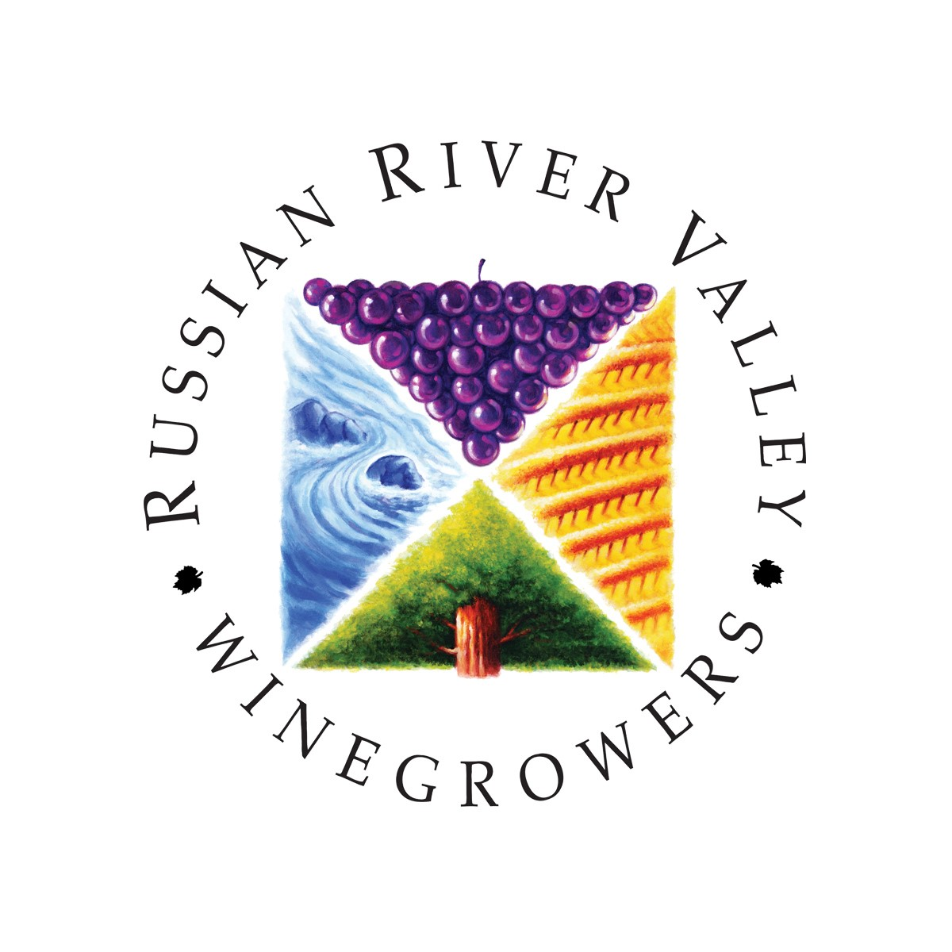
WINERY READINESS TO REOPEN

The collaborative team in the Sonoma Valley have shared their program with all of the AVA groups in Sonoma County. Please see the checklist below.

As we gradually returns to living in a post-COVID world, we must all accept the responsibility to protect our community. In that spirit, Sonoma Valley Chamber, Sonoma Valley Vintners & Growers Alliance and the Sonoma Valley Visitors Bureau have developed Sonoma Valley Safe to support our businesses in taking the necessary steps to keep customers and employees safe and communicate with our guests that Sonoma County is committed to maintaining the highest safety standards to protect the health and welfare of employees, guests, and our community while providing world-class hospitality.

In order to become a Russian River Valley safe winery/tasting room, please certify that you have done the following:

Business Mitigation Checklist
- Review the Business Mitigation Checklist As you build your business plan to incorporate the necessary protocol to reopen once allowed by local and/or state health orders, review the checklist, required by the Sonoma County Health Officer, to ensure you are meeting or exceeding necessary requirements to reopen.

Best Management Practice Guidelines
- Read the Best Management Practice Guidelines for suggested approaches to quickly and safely reopen your business, once allowed by local and/or state health orders.
  - Tasting Room Guidance by California Wine Institute

Business Self-Certification Assessment

- Prior to reopening, complete the Sonoma County Business Self-Certification Assessment, committing to meet or exceed the requirements of the Business Mitigation practices put into place by the County of Sonoma to prevent the spread of COVID-19.
- Download and print your certificate. Businesses should retain a copy of the Self-Evaluation & Certification certificate on-site at the business location.
- Once your business is self-certified, submit a copy of your certificate to info@rrvw.org

Download, Print & Post Signage

- Once your Sonoma Safe certification form has been submitted to info@rrvw.org you will receive an email with a link to the Sonoma Safe Wineries dropbox folder featuring the digital assets. You are encouraged to use these assets to develop signage for your place of business. Wine Road will also be mailing you one sign, one window cling and one social distancing sign. You may download and order more as needed.
Consider the following:
  - Provide signage at each entrance of the facility to inform employees and customers of requirement to wear face mask while inside your place of business.
  - Provide signage regarding the social / physical distancing protocol at the facility; persons to maintain a minimum six-foot distance from non-household members as much as practicable and not engage in any unnecessary physical contact.
  - Provide signage regarding proper hand washing techniques posted at all handwash sinks.

Share your Status

- Share your Sonoma Safe Wineries certification by incorporating the Sonoma Safe Wineries mark on the following:
  - Winery website
  - Social media outlets
  - Printed collateral, handouts
- Display window cling in entry of place of business.

